Contact: Neil White
The Nautilus Publishing Company
neilwhite3@yahoo.com
662-513-0159

An Unforeseen Life
By Mary Ann Connell
Publication Date: April 11, 2017

“Cry, laugh, and applaud as you relive the remarkable life of Mary Ann Strong Connell — beloved
daughter, wife, mother, friend, and gifted writer.”
Robert Khayat,author of The Education of a Lifetime

“Mary Ann Connell’s memoir takes us on a fascinating journey, from the trauma of the death of her little brother to honors as a student at Ole Miss, then to life as a young wife in the mysterious Delta before returning to her alma mater to serve as the university’s lawyer during a time of upheaval and renaissance. It is not only an ‘unforeseen life,’ it is a remarkable story.”

Curtis Wilkie, author of The Fall of the House of Zeus

“An Unforeseen Life is an extraordinary account of an extraordinary career – deeply reflective, unfailingly wise, and impeccably charming. Mary Ann Connell’s story passes through some of Mississippi’s most turbulent times, but her guidance as a storyteller, as it was as a pioneering attorney, is steady and spirited. And, as a bonus, she will more than once make you laugh out loud.”

Jonny Miles, author of Dear American Airlines and Want Not

“Mary Ann Connell was a wise and watchful observer and participant – especially as university attorney and a pioneer for women’s rights – during a transformational era at Ole Miss. Her memoir moves quickly through a series of vignettes – some sobering, some humorous, but all well told. Highly recommended.”

Dan Jordan,President Emeritus, Thomas Jefferson Foundation (Monticello)

“An Unforeseen Life illuminates a corner of Mississippi’s turbulent recent past not often given voice. The world of white, middle-class, privilege seen through the eyes of a curious girl, an observant young woman, a busy wife and mother turned lawyer and advocate is one seldom seen. Mary Ann Connell ushers readers from quiet Mississippi hill country to encounters with national leaders and statewide political forces. This is a journey readers will not want to miss.”
Margaret Love-Denman, author of Daily, Before Your Eyes and Story Matters

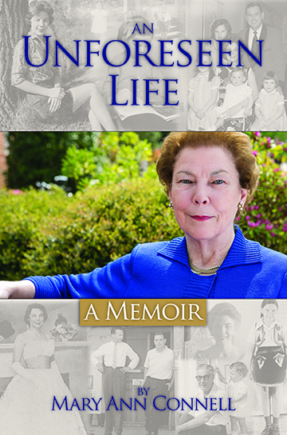

OXFORD, MS —“If it’s a boy,”Bill Strong announced to a crowded courtroom in Louisville, Mississippi,“I'll send up black smoke; if it’s a girl, I'll send up white.”
A few hours later, white smoke was billowing from the Strong’s chimney.This smoke — determined by gender — would come to define Mary Ann Strong Connell’s life in ways she never could have expected.
Jonny Miles, author of Dear American Airlines, said Connell’s story is “deeply reflective, unfailingly wise, and impeccably charming.”
When Connell was eight, firetook the life ofher younger brother. She blamed herself for the accident, and guilt became a motivator for the remainder of her remarkable life.

In An Unforeseen Life readers will walk with Connell through a different kind of firestorm as she becomes one of the first women practicing law in Oxford, Mississippi. The scenes continue to unfold when sheconvinces the Grand Wizard of the Ku Klux Klan to move his marchoffof the Ole Miss campus.
Her readers will share in her painas she is called as an adverse witness in the wrongful termination trial of football coach Billy Brewer, who had once been her classmate at Ole Miss, andthe exhaustion and difficulty of two NCAA investigations.
There are lighter moments when Connellwarns a first-year law student named John Grisham “if you don’t get serious, you’ll never succeed at the practice of law,” in addition to a battle with Oxford’s colorful mayor John Leslie (who took to calling her “The Sewer Queen”) anda client who pays her with a sack of coons.
We witness the character growth of those around her, including her husband, whose conservative beliefs about women began to erode as he saw her succeed. We applaud her when she enrolls in law school with four young children and when she attends Harvard Law School for an advanced degree(alongside fellow classmate Barack Obama).
An Unforeseen Life is a powerful memoir about a woman who embracedwhat she could and tried to make the most of her life, despite an underlying sadness. Her story is a funny, touching account of a life “most richly blessed” if sometimes in unexpected ways.
ISBN: 978-1-936946-79-2■ Hardcover with dust jacket■ 320 pages ■ $24.95

Mary Ann Connell practices law with Mayo Mallette, PLLC. She served as university attorney for the University of Mississippi from 1982 to 2003. She served as the school board attorney for the Oxford, Mississippi School District from 2003 to 2013. She has taught courses in higher education law, school law, legal research and writing; business law and employment law. She is a frequent presenter at national conferences on subjects involving higher education and school law. She is a past president of the National Association of College and University Attorneys; past president of the Mississippi Council of School Board Attorneys, and a fellow of the Mississippi Bar Foundation. She received the Distinguished Service Award from the National Association of College and University Attorneys; the NAACP Freedom Award for life-long service in the area of education and civil rights; the Mississippi Women Lawyers Association Outstanding Woman Lawyer in Mississippi Award; the University of Mississippi Chancellor’s Award for outstanding contributions toward increasing diversity, and the Mortar Board National College Senior Honor Society Award for outstanding teacher of the year. In 2015, she was inducted into the Ole Miss Alumni Hall of Fame.

Events for An Unforeseen Life
Monday, April 10—Louisville, MS Tuesday, April 11—Oxford, MS
Winston County Library Off Square Books
11:30 AM 5:00 PM

Wednesday, April 19—Memphis, TN Tuesday, April 25—Jackson, MS
Memphis Country Club Lemuria Books
2:00 PM 5:00 PM

Thursday, May 4—Clarksdale, MS Thursday, June 15—Brentwood, TN
Carnegie Public Library Reliant Bank/Carothers Parkway—Cool Springs
5:00 PM 5:00 PM

Thursday, July 13—Destin, FL Saturday, August 19—Jackson, MS
Sandestin Hilton Mississippi Book Festival
Mississippi Bar Price-Prather Luncheon Mississippi State Capitol

